**Superstore Sales Dashboard**

With the given dataset, accomplish the following objectives,

1. Create a dashboard with filters, KPI’s, charts, and maps.
2. Through the charts provide valuable insights thus performing data analysis.
3. Also perform data analytics with sales forecasting, in other words using historic data apply time series analysis to generate sales forecast for the next fifteen days.
4. Provide actionable insights and recommendation.

Data Transforming:

1. Deleting empty columns.
2. Replacing values of #N/A to 0 and changing data type to whole numbers.

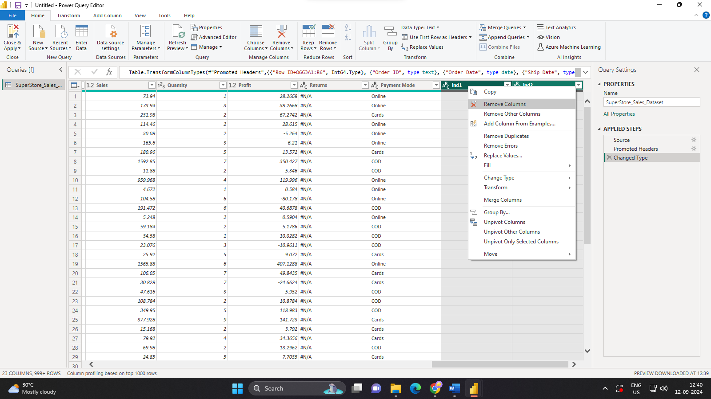

Clustered Bar Chart:



